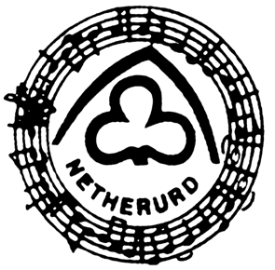
Netherurd Singing Circle

We are a group of past and present members of Girlguiding UK who get together for the opportunity to sing together, enjoy Netherurd, and share our interest with other Guiding members.

We have two weekends at Netherurd each year, as well as a day meeting and occasional other events. We also have the opportunity to participate in other events at Netherurd and elsewhere. We support Netherurd with donations or donations in kind on a regular basis. Fundraising takes place during a December weekend when we have a weekend based around a Christmas theme.

Membership is open to any interested member of Girlguiding UK (past or present) aged 18+. Our annual subscription is £7, due on 22 February each year, payable by standing order, or by cheque made payable to Netherurd Singing Circle. If you would like to join, please complete the form below, and email to the Webmaster at netherurdsingingcircle@gmail.com who will pass it on to the current secretary.

----------------------------------------------------------------------------------------------------------------

I wish to apply for membership of the Netherurd Singing Circle.

Name_________________________________________ Title ________________

Address ____________________________________________________________

___________________________________________________________________

_____________________________________________ Post Code ____________

Tel No. _____________________________________________________________

Email Address _______________________________________________________

Position in Guiding (past or present) ______________________________________

Please send me details of how to pay my membership subscription.

